SQL QUERIES USED
- Problem Statement 1:- Analyse the key metrics of a business - Total Revenue, Average Order Value, Total Pizzas Sold, Total Orders, and Average Pizzas per order.

- Total Revenue
SELECT SUM(total_price) AS total_revenue FROM pizza_sales;

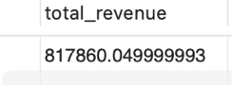

- Average Order Value
Select (SUM(total_price) / Count(Distinct order_id)) AS Avg_Order_value FROM pizza_sales;

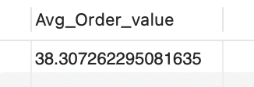

- Total Pizzas Sold
Select SUM(quantity) AS total_pizzas_sold FROM pizza_sales;

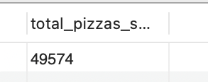
- Total Orders
SELECT COUNT(DISTINCT order_id) AS Total_Orders FROM pizza_sales;
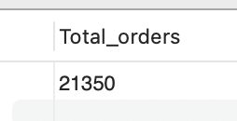

- Average Pizzas Per Order
SELECT CAST(SUM(quantity) AS DECIMAL(10,2)) /
CAST(COUNT(Distinct order_id) AS DECIMAL(10,2)) AS Avg_pizza_per_ord FROM pizza_sales;

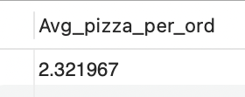
- Problem Statement 2:- Analyse the daily trend for the pizza orders
SELECT
DAYNAME(STR_TO_DATE(order_date, '%Y-%m-%d')) AS order_day,
COUNT(DISTINCT order_id) AS total_orders
FROM
pizza_sales
WHERE
order_date IS NOT NULL
GROUP BY
DAYNAME(STR_TO_DATE(order_date, '%Y-%m-%d'));

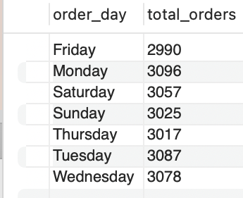

- Problem Statement 3:- Analyse the monthly trend for the pizza orders.

SELECT MonthName(STR_TO_DATE(order_date, '%Y-%m-%d')) AS order_day,
COUNT(DISTINCT order_id) AS total_orders
pizza_sales
WHERE order_date IS NOT NULL
GROUP BY MonthName (STR_TO_DATE(order_date, '%Y-%m-%d'));
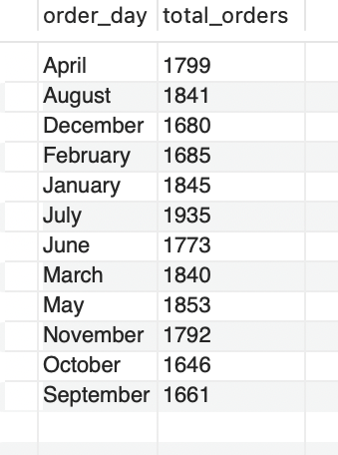

- Problem Statement 4:- Analyse the % of sales by Pizza Size.
SELECT pizza_size, CAST(SUM(total_price) AS DECIMAL(10,2)) AS Total_Revenue,
CAST(SUM(total_price) * 100 / (SELECT SUM(total_price) FROM pizza_sales) AS DECIMAL(10,2)) AS PCT
FROM pizza_sales
GROUP BY pizza_size
ORDER BY pizza_size;

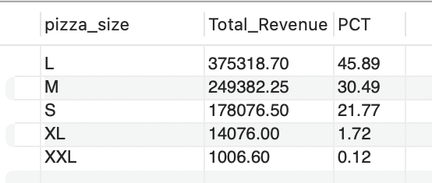
- Problem Statement 5:- Analyse the % of sales by Pizza Category.
SELECT pizza_category, CAST(SUM(total_price) AS DECIMAL(10,2)) as total_revenue,
CAST(SUM(total_price) * 100 / (SELECT SUM(total_price) from pizza_sales) AS DECIMAL(10,2)) AS PCT
FROM pizza_sales
GROUP BY pizza_category

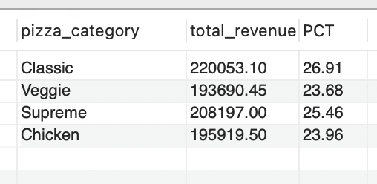

- Problem Statement 6:- Analyse the top 5 Pizzas by Revenue
SELECT pizza_name, SUM(total_price) AS Total_Revenue from pizza_sales
Group BY pizza_name
ORDER BY Total_Revenue DESC
LIMIT 5;
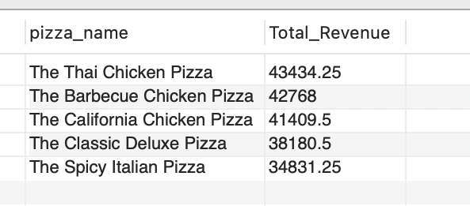

- Problem Statement 7:- Analyse the bottom 5 Pizzas by Revenue.
SELECT pizza_name, SUM(total_price) AS Total_Revenue
FROM pizza_sales
GROUP BY pizza_name
ORDER BY Total_Revenue
LIMIT 5;
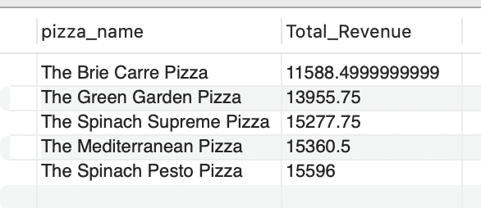

- Problem Statement 8:- Analyse the top 5 Pizzas by Quantity.
SELECT pizza_name, SUM(quantity) AS Total_Pizza_Sold
FROM pizza_sales
GROUP BY pizza_name
ORDER BY Total_Pizza_Sold DESC
LIMIT 5;
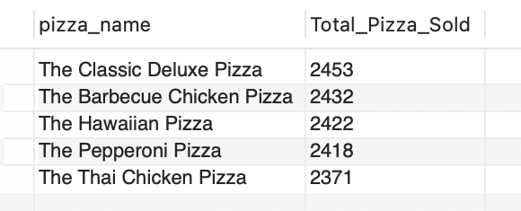

- Problem Statement 9:- Analyse the Bottom 5 Pizzas by Quantity.
SELECT pizza_name, SUM(quantity) AS Total_Pizza_Sold
FROM pizza_sales
GROUP BY pizza_name
ORDER BY Total_Pizza_Sold ASC
LIMIT 5;
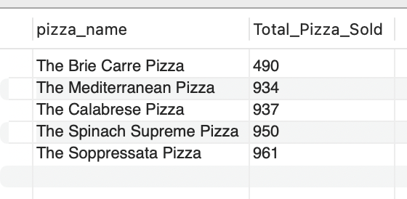
- Problem Statement 10:- Analyse the top 5 Pizzas by Order.
SELECT pizza_name, COUNT(DISTINCT order_id) AS Total_Orders FROM pizza_sales
GROUP BY pizza_name
ORDER BY Total_Orders DESC
LIMIT 5;

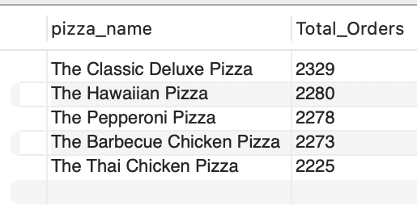
Problem Statement 11:- Analyse the bottom 5 Pizzas by Order.
SELECT pizza_name, COUNT(DISTINCT order_id) AS Total_Orders
FROM pizza_sales
GROUP BY pizza_name
ORDER BY Total_Orders ASC
LIMIT 5;
